Lab 1 – Check Hadoop Cluster health

# Login to CM web UI

* Login to CM

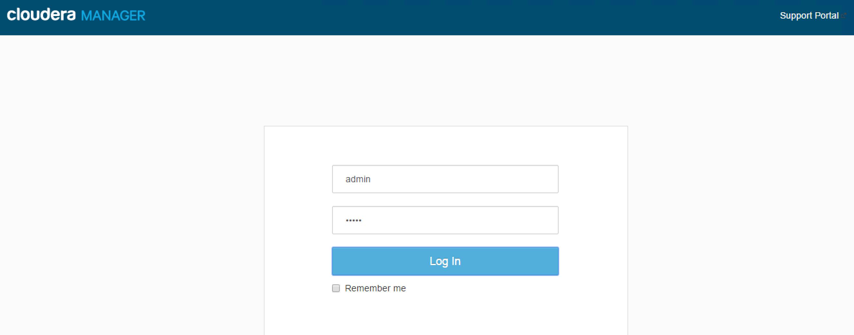

* Validate all services are in good health status, if not fix the issues prior to proceeding

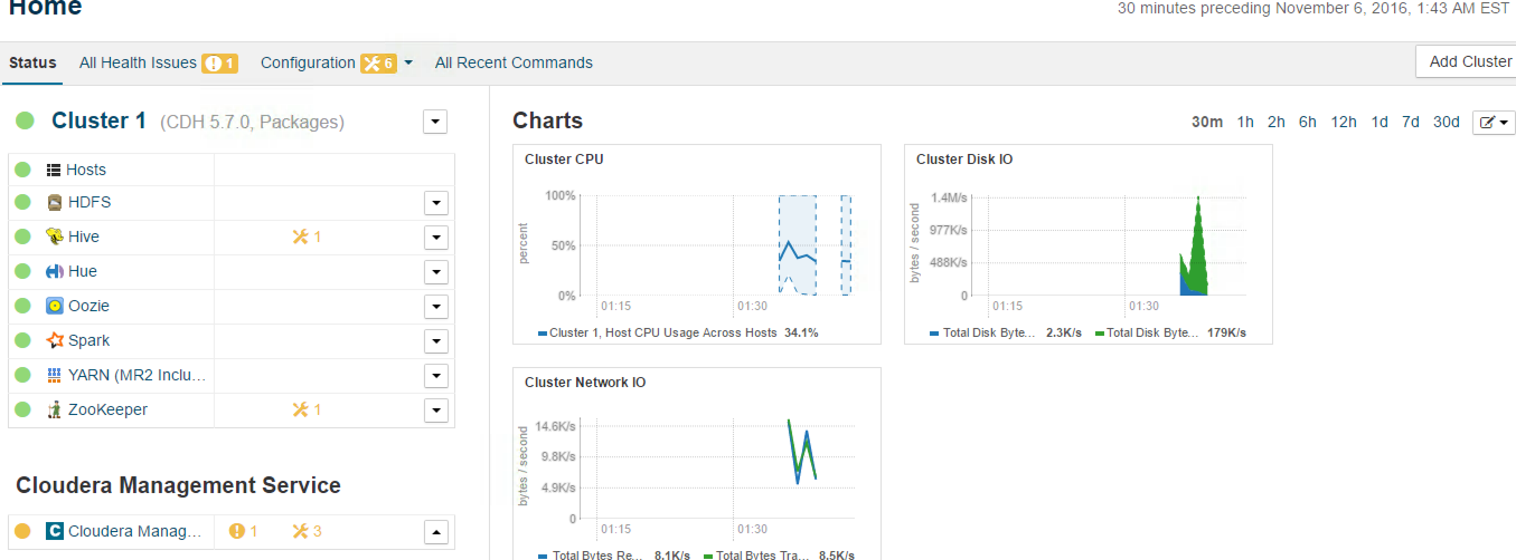

# Login to CM node and execute health check script

* Login to Cloudera manager node from command
* Download script from
* Execute script as hdfs user